The Hexagon of Opposition:
Thinking Outside the Aristotelian Box
Gregory A. Boyd, Thomas Belt, Alan Rhoda

It has traditionally been believed that omniscience means God’s knowledge of the future may be expressed exclusively in terms of what either will or will not come to pass. One common line of reasoning supporting this traditional belief is the following:

P1: All propositions are either true or false (bivalence).
P2: God knows the truth value of all propositions (omniscience).
P3: The future can be exhaustively described in terms of what either will or will not come to pass.
C: Therefore, God knows the future exclusively as that which either will or will not come to pass.

The argument is formally valid. Accordingly, those who deny the conclusion (C), such as open theists, have to deny one or more of the premises. Some deny the first premise (P1) and argue that propositions expressing future contingencies are neither true nor false. Others deny the second premise (P2), arguing that the truth value of propositions about future contingencies is logically impossible to know and thus not within the domain of God’s omniscience. For reasons too involved to explore presently, we find both positions to be problematic. We also deem such moves unnecessary to the denial of the conclusion (C), for, we shall argue, the third premise (P3) can be plausibly denied. This premise, we maintain, is arbitrarily restrictive. There are three, not two, distinct modes in terms of which future events may be described. It may be that (1) a future event S will obtain and it may be (2) that S will not obtain. Both of these possibilities are countenanced by P3. What P3 overlooks, however, is that it may also be the case (3) that S might and might not obtain.

If we grant that there are three, not two, distinct modes in terms of which future events may be described, then it is not the case that the future can be truly described solely in terms of what either will or will not come to pass. And if, in fact, the future cannot be truly described solely in terms of what either will or will not come to pass, then it follows that an omniscient God will not know the future solely in terms of what either will or will not come to pass. Rather, an omniscient God must also know the future partly in terms of what might and might not come to pass.

To say that S might and might not obtain is to say that S’s obtaining is indeterminate— neither inevitable nor impossible. The logical possibility of S being indeterminate is implicit in the structure of a future-tense Square of Opposition modeled after the traditional Square of Opposition from Aristotelian categorical logic. But this possibility has been largely overlooked in Western philosophy which has tended to assume that the future could be expressed solely in terms of what either will or will not come to pass. The structure of the Square is partly to blame, for it fails to make the logical possibility of genuine indeterminacy sufficiently explicit. When we make this possibility explicit, we find that the Square of Opposition transforms into a Hexagon of Opposition, in light of which it becomes clear how one may affirm genuine indeterminacy and thus deny (C) while at the same time affirming bivalence (P1) as well as God’s knowledge of the truth value of all propositions (P3).

In this essay we first show how the future-tense Square of Opposition allows for the possibility of a partly indeterminate future (I). We then point out two problems with the Square with respect to its ability to handle future indeterminacy (II). Following this, we demonstrate how a consistent working out of the logic of the Square leads to a future-tense Hexagon of Opposition (III). After highlighting several advantages of the Hexagon over the Square (IV) we conclude by applying insights gained from the Hexagon to assess the assumption (P3) that the future can be exhaustively described in terms of what either will or will not come to pass as well as the conclusion (C) that God knows the future exclusively as that which either will or will not come to pass.

I. Indeterminacy and the Square of Opposition
We begin by considering the Square of Opposition as it concerns S’s obtaining.

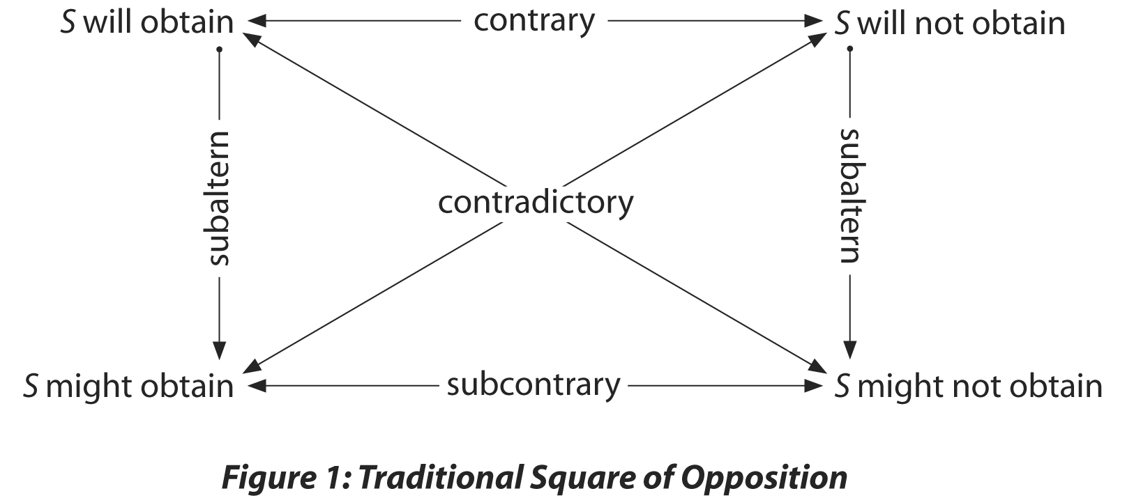

Now, several observations about the Square’s treatment of S’s obtaining are worth noting. On the standard interpretation of the Square, the contraries “S will obtain” and “S will not obtain” cannot be conjointly true, but they may be conjointly false. Conversely, while the subcontraries “S might obtain” and “S might not obtain” cannot be conjointly false, they may be conjointly true. Most significantly, we must note that when both subcontraries “might” and “might not” are true, contraries “will” and “will not” are both false, for “S will obtain” and “S might not obtain” are contradictories, as are “S will not obtain” and “S might obtain.”

These observations already expose the arbitrary restrictiveness of P3, for P3 simply denies that propositions expressing conjointly true subcontraries “might” and “might not” are ever true. To say the same thing a different way, P3 denies that propositions expressing the logically possible negation of both contraries “will” and “will not” are ever true. P3 mistakenly treats the contraries “will” and “will not” as though they were contradictories, subject to the law of excluded middle, and thus assumes that they together exhaust the logical possibilities. P3 reflects the traditional tendency to insist that either it is true that “S will obtain” or it is true “S will not obtain,” as though these two possibilities were mutually exhaustive, which is why it supports the traditional conclusion that God, by virtue of knowing the truth value of all propositions, necessarily knows whether S will or will not obtain. According to the Square, however, it may be false that “S will obtain” and false that “S will not obtain,” just in case it is true that “S might and might not obtain.” Again, “will” and “will not” are contraries, not contradictories, so while both cannot be true, both may be false. And “might” and “might not” are subcontraries, not contraries, so both cannot be false, but both may be true.

Of course, S will end up either obtaining or not. But, as the Square reveals, this does not imply that it is now true that either “S will obtain” or “S will not obtain.” The logical possibility of a true proposition expressing conjoined subcontraries reveals that the truth condition of future tense propositions is not found in what eventually comes to pass but in the state of things at the time the truth claim is made.

To illustrate, the truth condition of the statement, “Hillary will be president in 2008,” uttered in 2004, is not found in the as yet non-existent state of reality in 2008, but in the state of reality in 2004. Is it in fact determinately the case in 2004 that Hillary will be president in 2008? The statement is false just in case it is either determinately the case in 2004 that Hillary will not be president in 2008 or indeterminately the case in 2004 that Hillary will be president in 2008. The second possibility reflects the state of affairs expressed by conjointly true subcontraries “might and might not” on the traditional Square: “Hillary might and might not be president in 2008.” If in 2004 it is true that Hillary “might and might not” be president in 2008, then it is false in 2004 that Hillary “will” be president in 2008 and false also that she “will not” be resident in 2008—even though Hillary will eventually turn out either to be president in 2008 or not.

This entails, of course, that it is logically possible that God, by virtue of knowing the truth value of all propositions, knows in 2004 that it is false that Hillary will be president in 2008 and knows it is false in 2004 that Hillary will not be president in 2008 just in case God knows in 2004 that Hillary might and might not be president in 2008.

II. Two Shortcomings in the Traditional Square
Why has the western tradition mostly assumed that the future can be exhaustively expressed in terms of what “will” and “will not” come to pass? Why has the logical possibility of future indeterminacy expressed by conjointly true subcontraries “might and might not” been mostly neglected in the western tradition? Why have the contraries “will” and “will not” been treated as though they were contradictories? Part of the explanation, we believe, lies in two curious features of the Square that tend to obscure the logical possibility of future indeterminacy.

First, we should note that while a determinate future can be expressed on the Square by the single propositions “S will obtain” and “S will not obtain,” there is no single proposition expressing future indeterminacy. To express this third possibility, we must conjoin the two subcontraries “might” and “might not.” In other words, determinacy (“will” and “will not”) is given primitive status on the Square, while indeterminacy must be inferred.

This asymmetry between determinacy and indeterminacy perhaps explains why “might” and “might not” have tended to be understood exclusively in terms of their individual subaltern relations to “will” and “will not.” That is, while “will” and “will not” have been allowed to express states of affairs, “might” and “might not” have tended to be limited to expressing merely the epistemological preconditions of those two determinate states. If it is true that “S will obtain,” it must also be true that “S might obtain,” viz. it must be possible for S to obtain. So too, for it to be true that “S will not obtain,” it must also be true that “S might not obtain,” viz. it must be possible for S not to obtain.

But what has not been adequately appreciated in the western tradition is that the subcontraries “might” and “might not” may be conjointly true and the contraries “will” and “will not” conjointly false. In this case, “might” and “might not” are no longer related as subalterns to “will” and “will not.” Rather, when they are conjointly true, they have the same relation to “will” and “will not” that “will” and “will not” have to each other. In other words, they express a third distinct possibility –future indeterminacy – that stands in a contrary relationship to both the positive future determinacy expressed by “will” and the negative future determinacy expressed by “will not.” For any possible future state of affairs, one of the three – “will,” “will not” and “might and might not” – must be true and the other two false.

But, because “might” and “might not” must be conjoined to play this third, indeterminate, contrary role, the possibility of their playing this role has been largely overlooked. Consequently, the possibility that the future is in some respects indeterminate and known by God as such has been largely overlooked.

There is a second, closely related observation we need to make about the Square. If we begin with the truth of one of the two determinate contrary poles, we can know the truth value of the other three poles. If, for example, “S will obtain” is true, then the subaltern “S might obtain” must also be true while both “S will not obtain” and “S might not obtain” must be false, the former because it is the contrary of “S will obtain” and the latter because it is its contradictory. By contrast, if we begin with a true “might,” we can only know that its contradictory “will not” is false. We can know nothing regarding the truth values of “will” and “might not.” It could be that “will” is true and “might not” false, or it could be that “might not” is true and “will” is false. The same applies if we begin with a true “might not,” in which case the contradictory “will” is false and either “might” is true and “will not” false or “will not” is true and “might” is false.

In other words, the Square allows us to falsify “will” with a single proposition—a “might not”—while leaving open the question as to the truth values of “might” and “will not.” The Square also allows us to falsify “will not” with a single proposition — “might” — while leaving open the question as to the truth values of “might not” and “will.” But, though the Square allows us to express “might and might not” through conjoined subcontraries, it gives us no way of falsifying this state of affairs while leaving open the question as to the truth values of “will” and “will not.” "In other words, to know that it is false that "S might and might not obtain," we must know that either "S will obtain" is true and “S will not obtain” is false or that “S will obtain” is false and “S will not obtain” true.

To achieve parity with the three truth claims the Square allows for, we must be able to falsify "might and might not" while leaving open the question of the truth values of the other two truth claims (will" and "will not"). Yet, to achieve this requires a fundamental revisioning of the Square, for we must posit a single proposition expressing "might and might not" just as we have for "will" and "will not,” and it must have the same relation to "will" and "will not" that they have with each other. What is more, we must posit a single contradictory proposition to "might and might not" which, by virtue of being true, can falsify “ might and might not," just as "will" and "will not" can each be falsified by a single contradictory proposition ("might not" and "might). This, we shall soon see, transforms the Square of Opposition into a Hexagon of opposition.

As with our first observation, the lack of parity between “will” and “will not,” on the one hand, and “might and might not,” on the other, reveals a prejudice toward determinacy within the traditional Square. The Square logically allows for indeterminacy but does not treat it on a par with determinacy. And given how influential the Square has been to the development of Western thought, we suspect that this inadequacy may help explain why the tradition has tended to assume that the future is exhaustively expressible in terms of what will and will not come to pass and thus that God knows the future exhaustively in terms of what will and will not come to pass.

III. The Hexagon of Opposition
We wish to explore a model that grants indeterminacy the same propositionally singular status as determinacy. Toward this end, we will use Q as a primitive operator meaning “It is indeterminately the case that…” alongside primitive operator Z meaning, “It is determinately the case that…”. We will also revise the Square in such a way that Q will be granted the same logical status as Z.

As we have stated, there are three, not two, distinct modes of being that may characterize the future. Using Q and Z as defined, we arrive at:

Z(S) = It is determinately the case that state of affairs S occur (“S will obtain”)
Z(~S) = It is determinately the case that state of affairs not-S occur (“S will not obtain”)
Q(S) = It is indeterminately the case that state of affairs S occur (“S might and might not obtain”)

Each of these propositions affirms a distinct metaphysical possibility concerning any possible future state of affairs. These possibilities are jointly exhaustive and mutually exclusive. As jointly exhaustive, at least one must be true for any meaningful future tense proposition. Thus we arrive at our first theorem:

        - (S) [(Z(S) ∨ Z (~S) ∨ Q(S)].

As mutually exclusive, if any one is true, then the other two must be false, giving us three additional theorems:

        - Z(S) ↔ ~Z(~S) ∧ ~Q(S)
        - Z(~S) ↔ ~Z(S) ∧ ~Q(S)
        - Q(S) ↔ ~Z(S) ∧ ~Z(~S)

Because no two can be true at the same time, while any two can be false at the same time, these three possibilities are related as contraries, which we can represent by the following Triangle of Contrary Relations.

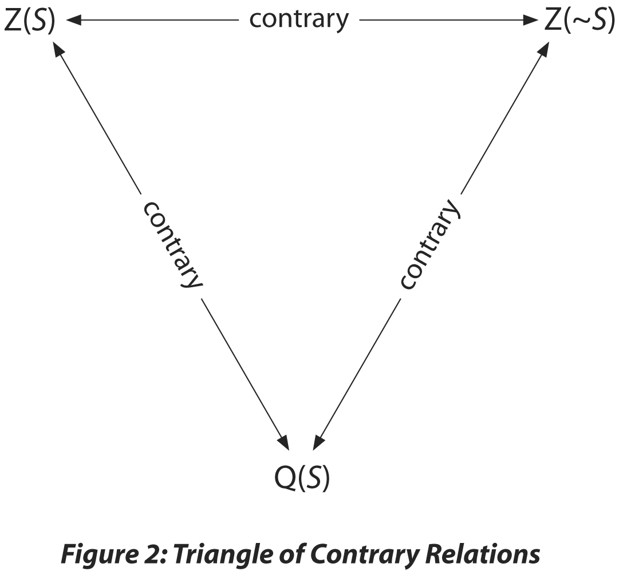

This Triangle of Contrary Relations generates a Triangle of Subcontrary Relations when we associate each possibility with its contradictory. Consider first Z(S) (“It is determinately the case that state of affairs S obtain”). The contradictory of Z(S) is, of course, ~Z(S) (“It is not determinately the case that state of affairs S obtain”) and can be illustrated as follows:

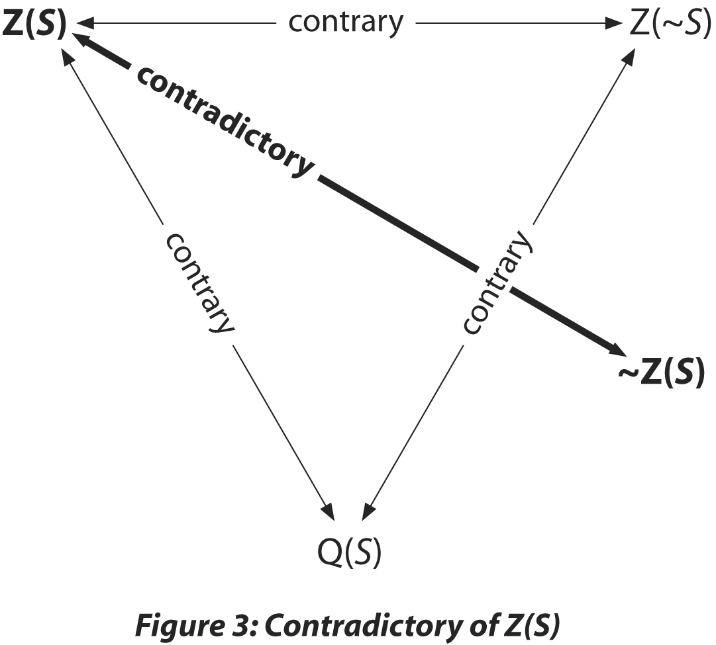

The contradictory of Z(~S) (“It is determinately the case that state of affairs not-S obtain”) is ~Z (~S) (“It is not determinately the case that state of affairs not-S obtain”) which we locate opposite its contradictory:

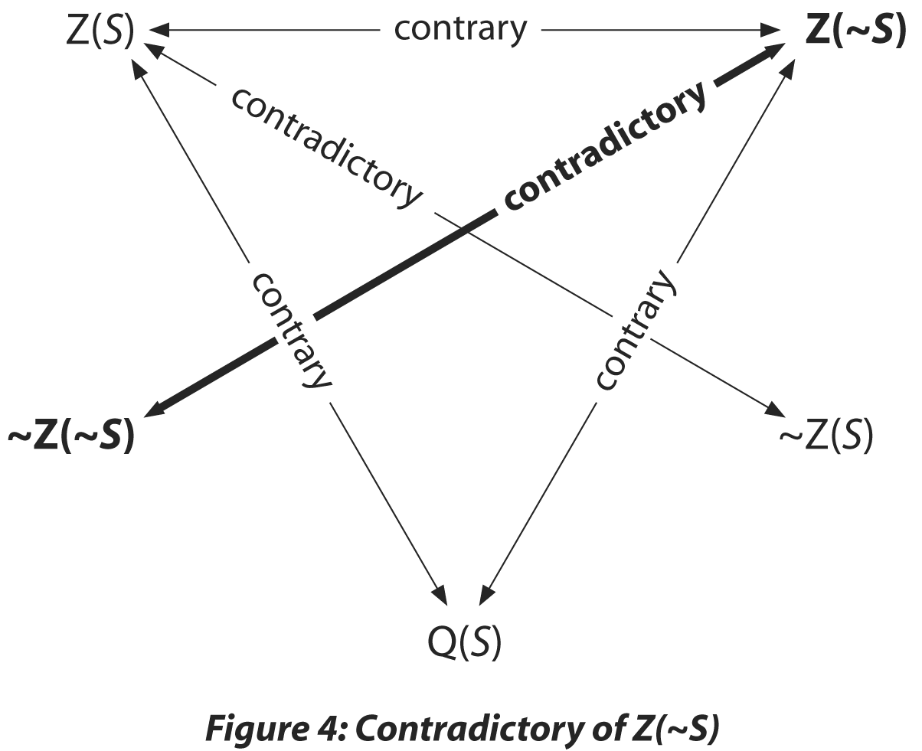

Lastly, the contradictory of Q(S) (“It is indeterminately the case that state of affairs S obtain”) is ~Q(S) (“It is not indeterminately the case that state of affairs S obtain”), illustrated as follows:

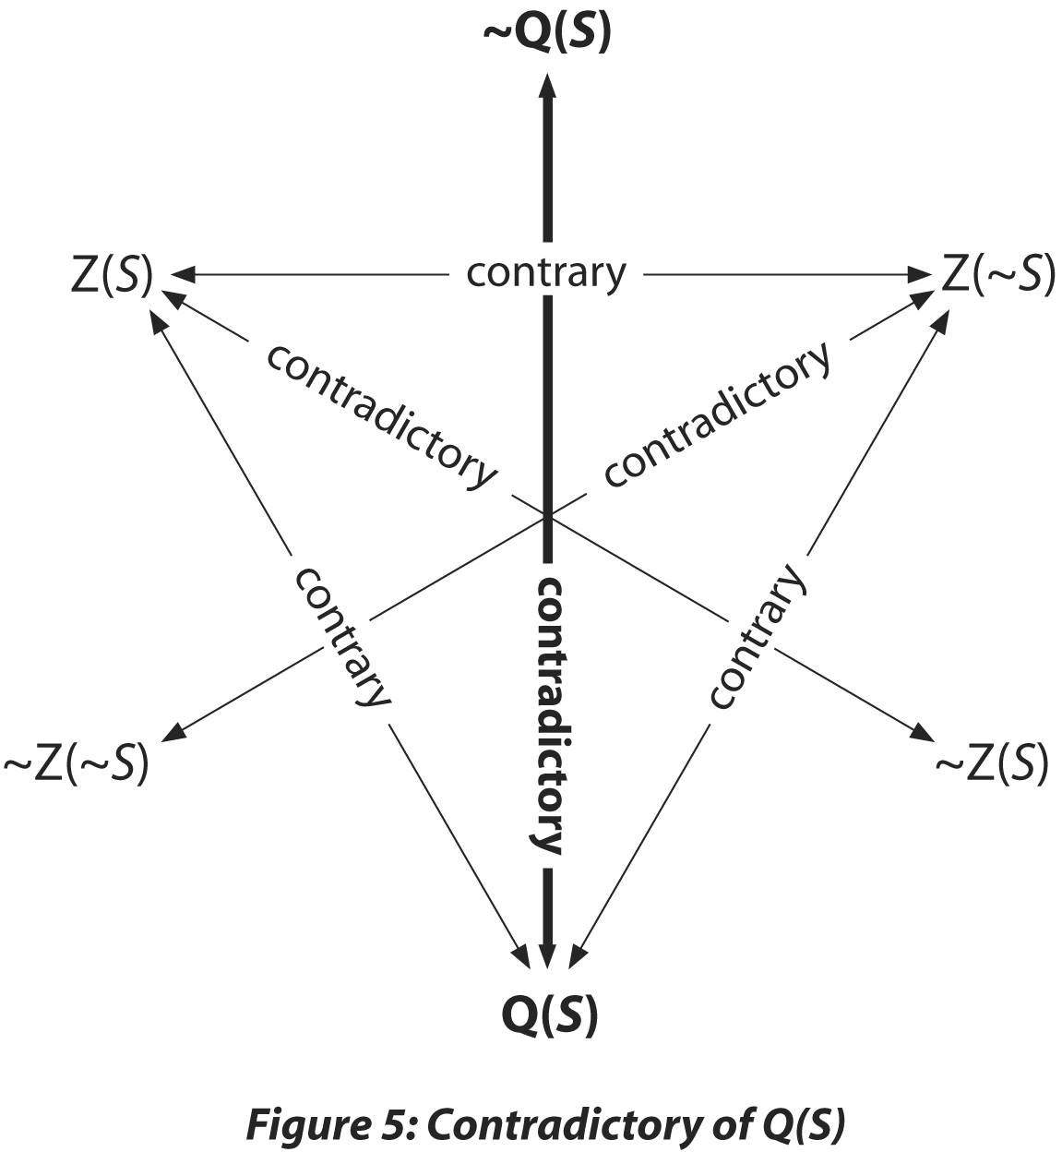

Note that the first two propositions above, Z(S) and Z(~S) (“will” and “will not”) and their contradictories are explicit on the traditional Square. But the third proposition, Q(S) (“might and might not”) and its contradictory ~Q(S) have now been made explicit.

Now let’s consider how the contradictories (~Z(S), ~Z (~S) and ~Q(S) are related to each other. Consider the pair ~Z(S) and ~Z(~S). Since Q(S) entails both ~Z(S) and ~Z(~S) (by Theorem IV), it is clear that they are conjointly true when Q(S) is true. It is equally clear that ~Z(S)and ~Z(~S) cannot be conjointly false. For if ~Z(S) is false, then Z(S) is true, and if ~Z(~S) is false, then Z(~S) is true. But Z(S) and Z(~S) cannot be conjointly true (by Theorems II and III), so ~Z(S) and ~Z(~S) cannot be conjointly false. The same results obtain mutatis mutandis for the other pairs, (~Z(S) and ~Q(S); ~Z(~S) and ~Q(S). So, for each pair, it is possible that both be true and not possible that both be false, which means that they are subcontraries. We thus arrive at a Triangle of Subcontraries overlapping with the Triangle of Contrary Relations.
.
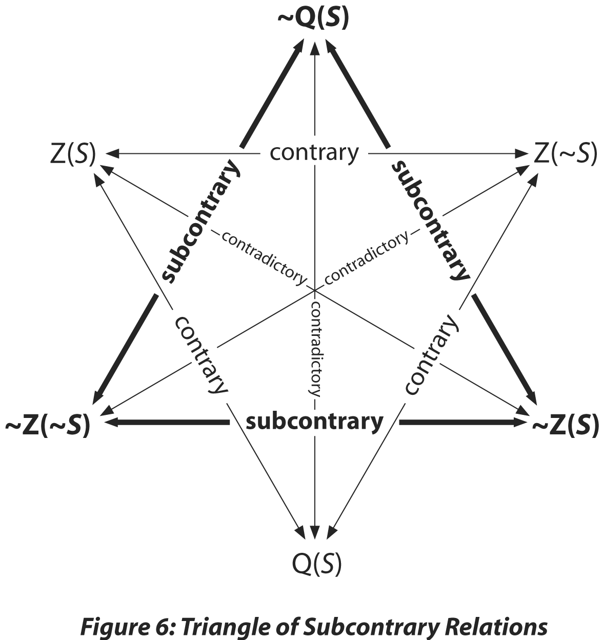

Thus far we have considered contrary, contradictory, and subcontrary relations. There remains one more logical relation to consider, namely, subaltern relations, which run outward from Z(S), Z(~S), and Q(S). We already know from the Square that ~Z(~S) is the subaltern of Z(S). Thus, if Z(S) (“will”) is true, the subaltern ~Z(~S) (“might”) is necessarily true. The same now applies to the relationship between Z(S) and the adjacent ~Q(S) (“not ‘might and might not’”). If Z(S) is true, ~Q(S) must be true. Likewise, if Z(~S) (“will not”) is true, the subaltern ~Z(S) (“might not”) is also true. The same subaltern relationship exists between Z(~S) and ~Q(S). If Z(~S) is true, ~Q(S) must be true. Lastly, Q(S) (“might and might not”) also has subaltern relations with the adjacent propositions. If Q(S) (“might and might not”) is true, both subalterns ~Z(~S) (“might”) and ~Z(S) (“might not”) are true.

As figure 7 below illustrates, the subaltern relations run from each of the three propositions forming our Triangle of Contrary Relations to each of the propositions forming the Triangle of Subcontrary Relations, completing a Hexagon of Subaltern Relations:

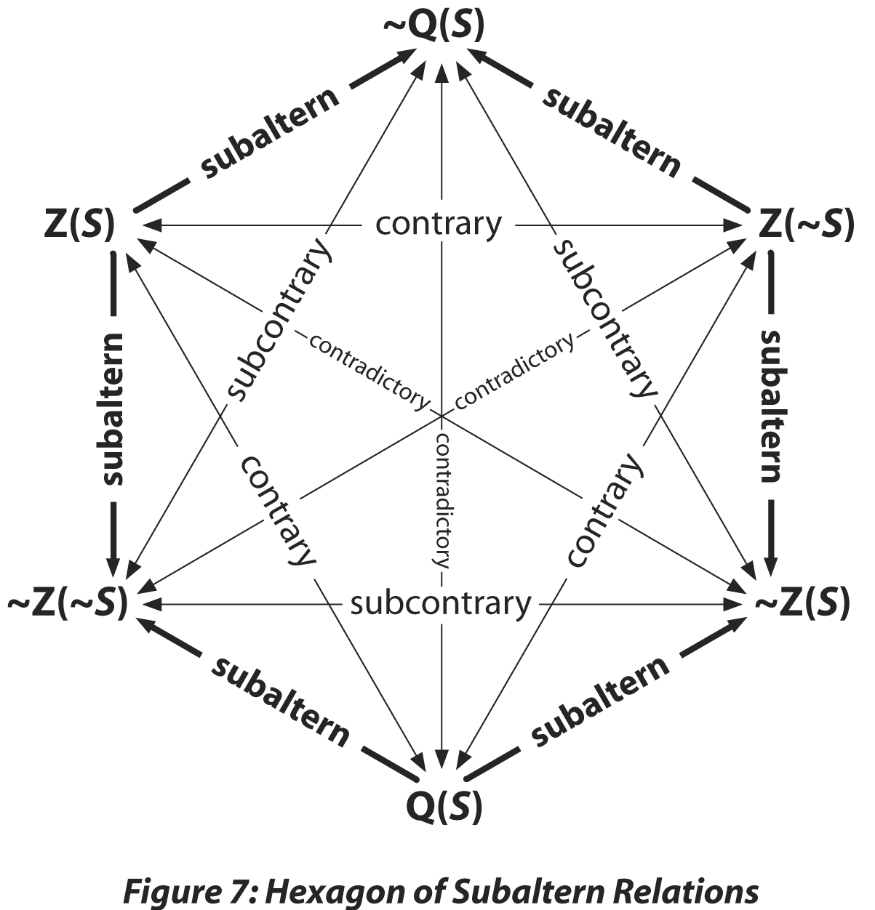

Note that the traditional Square of Opposition is still present in the Hexagon. We have simply enlarged and completed it. Indeed, one should notice that in completing the traditional Square we have uncovered two other intersecting Squares of Opposition, each exhibiting different truth functions but preserving the same logical relations. The traditional Square of Opposition is composed of contraries Z(S) and Z(~S) and subcontraries ~Z(~S) and ~Z(S). A second Square is composed of contraries Z(S) and Q(S) and subcontraries ~Z(S) and ~Q(S). A third Square is composed of Z(~S) and Q(S) and subcontraries ~Q(S) and ~Z(~S). The three squares may be highlighted as follows:

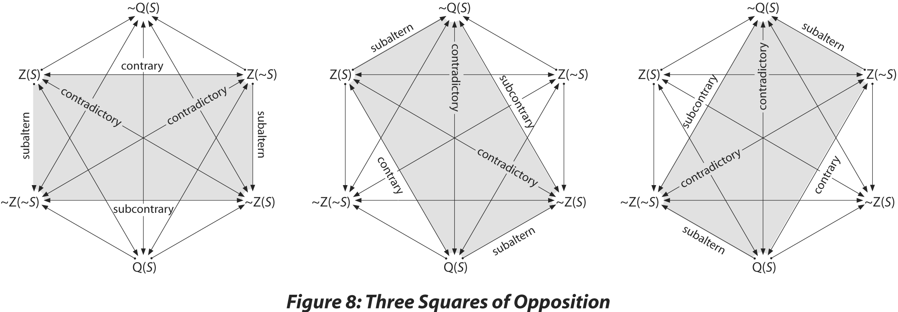

What we have in effect done is complete and correct the future tensed Square by replicating it three times from the vantage point of the three logically possible modes of being that the traditional Square allows for but does not adequately express. As with the traditional Square, the logical possibility of all three modes is implicit in each of the three Squares, but made explicit only when all three Squares are joined together, forming what we call the Hexagon of Opposition. It exhibits all the contrary, subcontrary, contradictory, and subaltern relations associated to the three logically possible modes of being.

IV. The Superiority of the Hexagon of Opposition
We may now more completely and elegantly account for the three logically possible modes of being and thus the truth values of all possible future tense propositions. The Hexagon’s advantages over the traditional Square in expressing future tense propositions include:

1. The Hexagon recognizes indeterminacy as a distinct mode of being about which we may offer true or false propositions (as opposed to the Square which only indirectly recognizes indeterminacy through conjointly true subcontraries). On the Hexagon of Opposition, indeterminacy is expressed by the operator Q, alongside the determinacy operator Z. The Hexagon thus recognizes indeterminacy in the same “propositionally singular” fashion as it recognizes determinacy.

2. Similarly, the Hexagon clarifies all the logical relations between all possible future tense propositions, whereas the traditional Square leaves some of these relations unexpressed. For example, the Hexagon clarifies the important difference between “might” (~Z(~S)) functioning as the subaltern of Z(S) and thus expressing the epistemological condition for Z (S) and falsifying “ (Z(~S)), on the one hand, and “might” (Q(S)) expressing an indeterminate mode of being, on the other. In other words, the Hexagon illustrates the truth that “might” and “might not” may independently be true or false as the subalterns of Z(S) or Z(~S) respectively, but when conjointly true (Q(S)) their relation to Z(S) and Z(~S) is contrary, not subaltern. As we noted earlier, this distinction is not made by the traditional Square, a fact that we suspect has contributed to the relative neglect of indeterminacy in the western tradition.

3. The Hexagon allows us to falsify Q(S) (indirectly present on the Square through conjointly true “might and might not”) while leaving open the truth values of Z(S) (“will”) and Z(~S) (“will not”). The Square, we have seen, allows this for Z(S) and Z(~S), but not for Q(S). Because the Hexagon places Q(S) on equal, contrary footing with Z(S) and Z(-S), in knowing any one of the three contrary proposition is true, we know the truth value of its contrary, subcontrary, contradictory and subaltern relations. But in knowing any one of the three contrary propositions as false, we leave open the truth value of the other two contraries.

4. By clarifying the difference between the subaltern relations of “might” and “might not” to “will” and “will not” when considered alone, on the one hand, and the contrary relation of “might and might not” to “will” and “will not” when considered conjoined, on the other, the Hexagon makes explicit the present tense truth condition of future tense propositions. The truth value of “S will obtain” or “S will not obtain” or “S might and might not obtain” is located not in what eventually happens, but in what is now the case. Stated otherwise, the Hexagon reveals that the truth of a future tense propositions about future contingents depends on when the truth claim is made. The Hexagon thereby reveals that the common philosophical assumption that the truth of all future tense propositions is timeless is misguided, for it arbitrarily assumes that all propositions expressing what “might and might not” obtain are false.
What then are we to make of the tenseless proposition, "S obtains at T"? In our view, it is an incomplete proposition in cases where S asserts a contingent state of affairs, for only necessary truths are timeless (viz. necessarily true at every moment). If a statement expressing the proposition "S obtains at T" is uttered prior to T, the statement is actually asserting the proposition "S will obtain at T" and is true just in case S will obtain at T, false that "S will not obtain at T" and false that "S might and might not obtain at T." If uttered subsequent to T, the statement actually asserts the proposition "S did obtain at T" and is true just in case S did obtain at T and false that "S did not obtain at T." And if uttered at T, the proposition "S obtains at T" actually asserts "S now obtains" and is true just in case S does in fact now obtain and false that "S does not now obtain." In other words, the meaning and truth value of a proposition expressing a contingent state of affairs depends on when the claim is made with respect to the time of the event in question.

If the temporal relationship between when a statement is uttered and the contingent state of affairs asserted is not known, there is, strictly speaking, no propositional meaning or truth value to speak of. A tenseless proposition asserting a temporally indexed contingent state of affairs is like the proposition X + 2 = 4 where X is unspecified. If X =2, it is true. If X= 3, if is false. And if X = banana, it is meaningless. But if X is unspecified, we must simply regard the proposition as incomplete and having no truth value. So too, "S obtains at T" is incomplete unless we know the temporal relationship between when the proposition is asserted and when the event in question is supposed to obtain (or not) -- that is, unless we know whether the proposition is actually asserting "S will obtain at T" or "S did obtain at T" or "S now obtains at T."

V. Conclusion
We believe that the Hexagon of Opposition has a wide range of applications. One of these, we are convinced, is clarifying the argument we presented at the beginning of this essay. What are we to make of P3? To recall, P3 stated:

The future is exhaustively described in terms of what either will or will not come to pass.

As we have seen, the traditional Square itself demonstrates that this premise is arbitrarily restrictive, for it allows for subcontraries “might” and “might not” to be conjointly true thus rendering their contradictories “will” and “will not” false. But the Square also helps explain why the tradition has tended to assume P3, for it is prejudiced toward determinacy by virtue of not giving indeterminacy equally primitive status with determinacy, as we’ve shown. The Hexagon makes the arbitrariness of P3—and the limitations of the traditional Square that contribute to P3—explicit.

The Hexagon makes it clear that there are no logical grounds for assuming the future can be expressed solely in terms of what “will come to pass” and what “will not come to pass.” From a strictly logical perspective, the future can only be exhaustively expressed in terms of what “will come to pass,” what “will not come to pass” and what “might and might not come to pass.” Hence, the Hexagon makes it explicit that it is at least logically possible that God, by virtue of knowing the truth value of all propositions, knows some of the future as what might and might not come to pass. Just in case “S will obtain” or “S will not obtain” is true, God knows that “S might and might not obtain” is false. And just in case “S might and might not obtain” is true, God knows that both “S will obtain” and “S will not obtain” are false.

Of course, one could hold that while propositions expressing what “might and might not” come to pass (Q(S)) are logically possible, as a matter of fact God has rendered them all false by creating a world in which the future is exhaustively settled and thus known by God as such. True enough. God could have done this. But the Hexagon makes it clear that God could conceivably have done otherwise. And this is enough to demonstrate that P3 is not true a priori and thus that omniscience does not logically entail that God knows the future exhaustively in terms of what will or will not come to pass.

In the final analysis, the extent to which the future is in fact open and/or settled is a contingent matter that must be ascertained on grounds other than pure logic. However, the Hexagon of Opposition clarifies that nothing in logic itself, and thus nothing in the definition of omniscience, constitutes grounds for concluding there are no true “might and might not” propositions. It thus makes explicit that the future is not by definition exhaustively settled and thus that God does not by definition know it as exhaustively settled.

For a discussion, see Alan Rhoda, Gregory Boyd, Thomas Belt, “Open Theism, Omniscience and the Nature of the Future,” (Publication Pending).
Some might at the outset object to the applicability of the traditional Square to future tensed propositions. Unlike "all" and "none" on the traditional Square, one could argue, "S will obtain" and "S will not obtain" are contradictories, not contraries. In response, if one grants that indeterminacy is real, ontologically speaking, there are three, not just two, possible future-tense propositions that may describe the future, as we’ve already suggested. All three are mutually exclusive, which means they cannot be contradictory. They can only be contrary. Not only this, but if we accept that “S will obtain” and “S will not obtain” are contradictories, we must deny that "S will obtain" is the contradictory of "S might not obtain" and that "S will not obtain" is the contradictory of "S might obtain." But then, we must wonder, what is the relationship between these propositions? Clearly "S will obtain" and "S might not obtain" cannot both be false (and so with "S will not obtain" and "S might obtain"). But, for reasons argued elsewhere, we argue they also cannot both be true (see A. Rhoda, G. Boyd and T. Belt, "Open Theism, Omniscience and the Nature of the Future”), Hence, one must be true while the other must be false, which makes “will” and “might not” contradictory (and so “will not” and “might”). The other relations of the traditional Square (contrary, subcontrary and subaltern) follow from this as illustrated above.
See G. Boyd, “Neo-Molinism and the Infinite Intelligence of God,” Philosophia Christi, 5”1 (2003), 187-204, and item, “Unbounded Love and the Openness of the Future: An Exploration and Critique of Pinnock’s Theological Pilgrimage,” Semper Reformandum: Studies in Honour of C.H.Pinnock, eds. S. Porter and A. Cross (Great Britian: Paternoster, 2003), 38-58.
Another way of stating this is to note that while “Hillary will be president” and “Hillary will not be president” are contrary, not contradictory, propositions, “Hillary is president” and “Hillary is not president” are contradictory. Temporal passage is marked by the transition from three possible modes of being regarding the future (“will,” “will not,” “might and might not”) to two possible modes of being regarding the present and past (“is,” “is not,” and “was,” “was not”).

